Attachment C – SUIP Workgroup Report – SUIP Review for discussion at January 2023 AAFCO Midyear Meeting
- SUIP #1. Nitrogen Free Extract and Carbohydrate Guarantees – “are no longer considered as necessary and meaningful”... This SUIP has been written as such since 1963.
  - The AAFCO Pet Food Committee (PFC) is updating the Pet Nutrition Facts box to modernize presentation of carbohydrate information hence this SUIP seems unnecessary.
    - Ask PFC if they accept removal of this SUIP?
    - Ask Feed Labeling Committee (FLC) if they accept removal of this SUIP?
  - If both PFC and FLC are aligned, then the WG recommends deletion of SUIP #1

- SUIP #2. Trade or Proprietary Names – “shall not be used in formulating definitions, etc”.
  - Language included already in ‘Guide to Submitting New or Modified Ingredient Definitions to AAFCO’ on page 337, (2), A, V: ingredient definition proposed name shall… “not include a trade name or be proprietary in nature.”
  - Propose to IDC that the Guide be edited on p. 337 as follows: If there is no B, it’s odd to have an A. Suggest moving “The proposed name shall:” to the end of line (2), then list each item as A, B, C, D and E.
  - The WG recommends deletion of SUIP #2.
- SUIP #3. Improve Stability. Language is already included in the Official Feed Term for “Stabilized (process)” as described on page 353 of the 2022 OP. Therefore, the WG recommends deletion of SUIP #3.
- SUIP #4. Ash and nutrient elements are not analytically equivalent.
  - “Ash” occurs in the OP in multiple places:
    - Page 148, PF4 (a) (2),(3)
    - Page 154, PF9 (3)A
    - Page 183, 184, 185, tables
    - Page 211, 212, 214, 216, 218, Affidavits
    - Page 231, Regulation 5, (B) (2)
    - Page 241, SUIP
    - Page 304, AOAC Check Data Table
    - Page 354, “Air ashed” – defined
    - Page 366, Whey solids, definition includes “ash”
    - Page 371, 9.20, 9.21, 9.22 definitions include “ash”
    - Page 375, 9.72, 9.74 definitions include “ash”
    - Page 376, 9.78 definition includes “ash”
    - Page 387, 24.7, 24.8 definitions include “ash”
    - Page 403, 33.7, 33.8 definitions include “ash”
    - Page 406, 33.25, 33.26, 33.27 definitions include “ash”
    - Page 419, 54.1 definition includes “ash”
    - Page 420, 54.2, 54.9, 54.10, 54.13 definitions include “ash”
    - Page 421, 54.14, 54.22, 54.23 definitions include “ash”
    - Page 422, 54.25 definition includes “ash”
    - Page 423, 57.1 definition includes “ash”
    - Page 440, 60.7, 60.72, 60.43 definitions include “ash”
    - Page 443, 60.84, 60.101 definitions include “ash”
    - Page 444, 60.111 definition includes “ash”
    - Page 447, 63.83 definition includes “ash”
    - Page 468, 73.305, 73.310 definitions include “ash”
    - Page 471, 74.1, 74.2, 74.3, 74.4, 74.5 definitions include “ash”
    - Page 473, all screenings must…”ash”…
    - Page 474, 81.1, 81.2, 81.3 definitions include “ash”
    - Page 486, 87.35 “sulfated ash”
    - Page 500, 87.118 definition includes “ash”
    - Page 503, 87.126 “acid insoluble ash”
    - Page 525, 93.9 definition includes “ash”
  - Laboratory Methods group provided input regarding various forms of “ash”, see Attachment A.
  - The WG recommends the IDC consider developing official feed terms for “ash”, “acid insoluble ash”, “air ashed” and “sulfated ash”.
  - After an official feed term for ash is accepted in the OP, the WG recommends subsequent deletion of SUIP #4.
- SUIP #5. Registration and Labeling of Silage Additive Products is covered on page 113 of the 2022 OP under the definition of “commercial feed” in Section 3(b) of the Model Bill. Therefore, the WG recommends deletion of SUIP #5.

- SUIP #6: Spent Bleaching Clay (SBC)
  - Attachment B provided by Katie Vassalli of the National Oilseed Processors Association (NOPA) and Chris Vervaet of the Canadian Oilseed Processors Association (COPA) explains the detailed history behind this SUIP.
  - The WG recommends sending this historical information to IDC for evaluation of SBC as a possible official feed term or for inclusion under an existing oilseed definition or as a new feed definition.
  - The WG recommends deletion of SUIP #6 because it carries no official stature as an SUIP and should be moved to another OP area.
- SUIP #7: Chews, Bones, and Toys for Pets and Specialty Pets
  - The WG recommends that this SUIP be incorporated into Section 3(b) of the Model Bill, as in Section 3(b) iii below.
  - The WG recommends editorial changes to Section 3(b) of the Model Bill by creating (b) i. and (b) ii.

When used in this Act:
…
(b) The term “commercial feed“ means all materials or combination of materials which are distributed or intended for distribution for use as feed or for mixing in feed, unless such materials are specifically exempted:
- Unmixed whole seeds and physically altered entire unmixed seeds, when such whole or physically altered seeds are not chemically changed or are not adulterated within the meaning of Section 7(a) of this Act, are exempt.
- The ________ by rule may exempt from this definition, or from specific provisions of this Act, commodities such as hay, straw, stover, silage, cobs, husks, hulls, and individual chemical compounds or substances when such commodities, compounds or substances are not inter – mixed with other materials, and are not adulterated within the meaning of Section 7 (a) of this Act.
iii. All chews, bones, toys and exercisers made of animal skin, hide, wood, or man-made (synthetic) material for Pets and Specialty Pets, whether flavor-coated or unflavored, – Hooves, Ears , Animal Bones, Ligaments, Snouts, Pizzles – unless the manufacturer, in its product labeling or advertising, makes any claim that the product is intended for use as an animal food, or that the product provides anything of nutritional value to the animal (i.e., “digestible“ or “high-protein“).

- The WG recommends IDC consider feed term for “rawhide” –(Part) generally refers to dermal tissue of beef. The basis for this recommendation is that the WG removed this sentence at the bottom of SUIP #7: “Rawhide generally refers only to beef, and many of these chews use other types of animal skins or hides”.
- The WG recommends deletion of Labeling Note regarding CFR – as this is understood.
- The WG proposes the addition of word “synthetic” after man-made for clarification in part iii.

- SUIP #8: Live Plants and Animals Distributed as Food for Pets and Specialty Pets Policy Statement
  - Attachments C and D provide the historical timeline and feedback from Dave Dzanis, one of the members of the original working group, regarding importance of maintaining this item.
  - The WG recommends discussion of this SUIP.
    - Perhaps include in Section 3(b) of Model Bill?
    - Consider whether these should be Common food items?
  - The WG would like to reconsider what to recommend after this discussion.
- SUIP #9: Dried Insects for Wild Bird Food
  - The WG recommends discussion of this SUIP, similar to SUIP #8.
  - If this SUIP will be maintained, then the WG recommends replacing the Example of BSFL with Dried Mealworms because BSFL is now defined in 60.117. See below.

SUIP# 9: Dried Insects for Wild Bird Food – Insects, all life stages, that are commonly found in the wild as North American wild bird food sources may be reared and dried for use in commercial wild bird feed. These insects are considered common food. The dried insects must be feed grade. The label must include the appropriate common name of the insect. Example: Dried Mealworms.

Attachments
A. Ash discussion
B. Spent Bleaching Clay historical information
C. Live Plant discussion: History
D. Live Plant discussion: Recent input from Dave Dzanis
Attachment A: Input from Lab Methods Committee regarding Ash
Hi Cathy,
Here is some information for you from a chemistry colleagues’ perspective:

As far as SUIP 4 on p. 241, I would completely agree with that statement. Several important nutrient elements will burn off during the Ashing process, with Nitrogen and Sulfur immediately coming to mind, but I’m sure there are a few others as well, plus some others that can have a low recovery/bias if the temperature is too hot or the time too long. As you may know, dry ashing used to be a common sample digestion technique but some nutrient elements were not obtainable this way. I did a very quick web search on this and this is one quick link < https://link.springer.com/chapter/10.1007/978-3-319-45776-5_16 > that includes the statement: Volatile elements at risk of being lost include As, B, Cd, Cr, Cu, Fe, Pb, Hg, Ni, P, V, and Zn. Elaine Hasty < Elaine.Hasty@cem.com > might have some expertise in this area if you want to reach out to her.
Unfortunately, I am not very familiar with the use of the term Air ashed on p. 345. Typically, ashing is done in a very limited oxygen and/or air environment to minimize combustion and loss of some of the mineral content that could occur with higher levels of O2. This might be used to indicate the “atmosphere” of the gas(es) used during the ashing process, and “air” is most commonly used in my experience, but again limiting the presence of air or oxygen is generally intended. In fact, it is usually recommended that the door of the muffle furnace is not open until the temperature drops to around 200C to prevent superheating or combusting which I have seen as bright read glowing embers in the ash if exposed to air while the crucibles are still at high temperature.
On p. 475, under Glucose Syrup, there is mention of Sulfated ash and I found one of several web references here: https://pharmabeej.com/how-to-perform-sulfated-ash/ Again, I am not familiar with this term, but this particular method seems to be used to semi-quantitatively determine the ashed or inorganic content of some materials? Some advantages of this technique is it doesn’t seem to require much equipment, it can be mostly done in an open environment, the combination of heat and acid likely destroys all the organic components. With the use of acid, this seems like a bit of a hybrid between dry ashing and wet digestion, but maybe that is why it has this special category?
Finally, on p. 492, there is mention of acid insoluble ash, which may be an important consideration. With plant based materials, often most of the ashed compounds are quite soluble in a dilute acid and some methods don’t even call for the acid-solubilized ash to be heated to bring the soluble nutrients into solution. That said, acid insoluble ash could represent some highly indigestible or potentially harmful materials, so I could see where this added test could have some value.
Again, I am somewhat unfamiliar with the original intent, or use, of these terms. For example, maybe air ashed just meant burning in a crucible in an open lab environment to qualitatively differentiate between the organic components that burn off at low temperature and the inorganic components that stay behind, of which many are minerals.

I hope you find this helpful,
Kristi
Kristi McCallum
Laboratory Manager
Division of Laboratory Services - Biochemistry Laboratory
P 303.869.9257
300 S. Technology Court, Broomfield, CO 80021
kristina.mccallum@state.co.us | https://ag.colorado.gov/labs

Attachment B: NOPA Response to AAFCO Inquiry Regarding Potential Revisions to the SUIP for Spent Bleaching Clay (SBC) November 2022

Background on NOPA’s Efforts on the Addition of SBC to Meal
• On July 9, 1993, a representative of a company which marketed bleaching clays for use in the food
industry, L.A. Salomon Inc., sent a letter to the Association of American Feed Control Officials (AAFCO)
asking about the acceptability of adding spent bleaching clay to oilseed meals used in animal feeds, as an alternative to disposal of spent clay in landfills.
• AAFCO’s Environmental Issues Committee: “The committee is concerned about feed becoming a ‘land‐fill’ for unwanted but disposable products but sees no reason why some products couldn’t be safely disposed through feedstuffs.”
• In May 1994, an AAFCO representative sent the letter to FDA for review.
• In September 1994, FDA responded that “To determine the safety of adding spent clay to animal feed,
information on the chemical composition of the spent bleaching clay is required. Since the clay adsorbs
heavy metals, the heavy metal content of the clay would be of primary concern.”
• In late 1994, AAFCO approached NOPA for information on the presence of certain heavy metals in spent clay (arsenic, cadmium, chromium, lead, mercury, nickel and zinc). On April 17, 1995, NOPA responded to AAFCO with “the results of recently completed analyses of fresh and spent bleaching clays for heavy metals.”
• On June 19, 1995, AAFCO submitted the results to FDA, suggesting “the possibility of adding back to the oilmeal stream a maximum of 0.2% (4 lbs of spent bleach clay/ton of oilmeal) at an integrated crushing/oil processing plant to dispose of the material in the oilmeal stream instead of the local landfill. At this level of add back, the ash and oil content of the spent clay does not change the nutritional or physical characteristics of the oilmeal.” and “ … the addition of up to 0.2% of ‘spent bleaching clay’ would not be detrimental to the oilmeal users in the feed industry.”
• On October 12, 1995, FDA found that “spent clay material can be safely added back to the oilseed meal at a maximum rate of 0.2% as requested.” (“The 0.2% level was set so that the amount would be minor and not result in changes that would affect the value (economic adulteration) of the meal.”)
• In 1996, AAFCO formally adopted the inclusion of “spent bleaching clay” in the “Statements of Uniform Interpretation and Policy” section of the AAFCO “Official Publication” (OP):
“Spent Bleaching Clay is bleaching clay which is derived from acid treated montmorillonite and used to clarify refined vegetable oil (corn, soy, cottonseed, peanut and canola oil) may be added to the oilseed meal, from which the oil is derived, at a maximum rate of 0.2%. The spent clay may contain color bodies, phospholipids and soaps.” (NOTE: THIS PROVISION DOES NOT REQUIRE THAT RESIDUAL OIL BE LEFT IN THE MEAL.)
Spent Bleaching Clay, USA ‐ FDA FOOD ADDITIVE PETITION (FAP)
In 2017, COPA began a petition with the FDA seeking to establish a 0.8% inclusion on an as is basis for spent bleaching clay (SBC) to be added to canola meal sold in the US. The current threshold for SBC added to protein meal in the US is 0.2%, as defined in the Association of American Feed Control Officials (AAFCO) publication under Statement of Uniform Interpretation and Policy (SUIP), #25.
The petition advanced through the process and was in the final phases of the review. The FDA provided
proposed language on what the final rule for addition of SBC at 0.8% would look like. Had the petition been approved, canola meal containing SBC, as well as any finished feed including canola meal with SBC would require a label. Canola meal containing SBC would be intended for use in non‐medicated feed but may be used in medicated feed where it has been demonstrated to not interfere with the bioavailability of particular drugs to animals.
Subsequently, the petition was withdrawn given the need for more analysis on SBC’s possible interaction with other feed medications. Industry also felt it was important to better understand the impacts a final FDA rule might have on the existing SUIP before moving forward.
Considerations for Modifying Existing SUIP
Based on preliminary assessment of the working group’s activities, COPA and NOPA would be in favor of
maintaining the SUIP as is. However, should it need to be removed from the SUIP, then we would ask that the terminology, as currently included, be incorporated into the existing definitions for soybean meal and canola meal, as is, and without changes to existing labeling requirements – which would maintain consistency with current U.S. industry practices. To that end, both COPA and NOPA would be happy to support AAFCO’s efforts to revise the existing definitions should the SUIP Working Group elect to go that route.

Industry Contacts
Katie Vassalli (AAFCO IDC Industry Advisory)
Vice President of Regulatory Affairs, National Oilseed Processors Association
Email: kvassalli@nopa.org | Phone: 202‐406‐0961 (mobile)

Chris Vervaet
Executive Director, Canola Oilseed Processors Association
Email: chris.vervaet@copacanada.com | Phone: 204‐956‐9500 (office)

Brittany Wood
Director, Canola Utilization
Canola Council of Canada
Email: Woodb@canolacouncil.org | Phone: 204‐982‐7763 (office)
Attachment C – Live Plant discussion (historical)
Historically:
IDC Minutes 2012 Midyear Reno, NV – workgroup commissioned
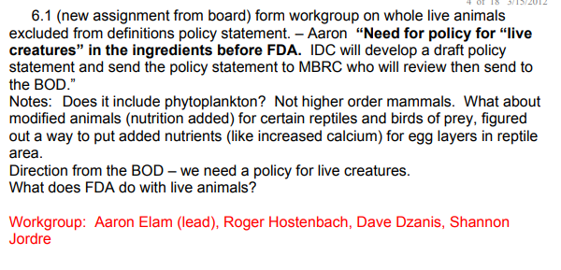
Annual Meeting 2012, Indianapolis:
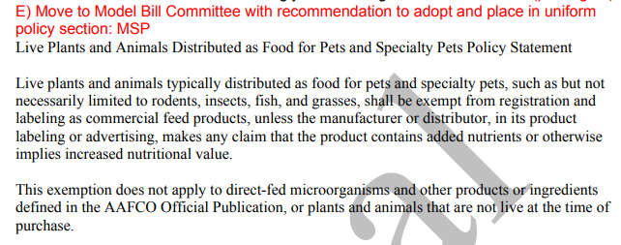
From MBRC Minutes 2013 Midyear Albuquerque, NM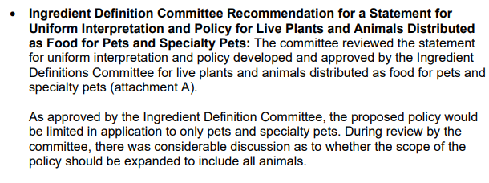
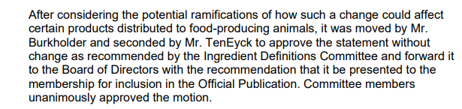

From General Business meeting 2013 Annual St. Pete Beach, FL
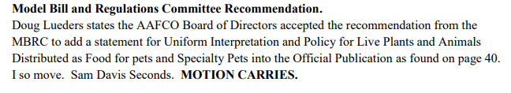

Attachment D: Live Plant SUIP#8 – Input from Dave Dzanis
2022 perspectives:
Thanks for asking about this, Angele. Please see my perspective below in red.
Is the SUIP still needed? Yes.
As an SUIP? Yes. I would consider this to be equivalent in intent to SUIP #7 re: rawhides, bones, etc. As I recall, after previous efforts by a WG to eliminate most if not all SUIPs, both #7 and #8 were retained because workable placement elsewhere could not be determined. What if any new plans are there to move SUIP #7 out of the SUIPs?
Has it been worked into regulations elsewhere? No. I believe this approach was considered, but dropped when it was determined that while you could exempt specified labeling requirements in some instances, you could not exempt a product from registration within the regulations per se.
Are there any consequences of it being removed? Yes, items such as live crickets, mice and cat grass (which comes as seeds or sprouts in a container that the purchaser has to water) would have to bear guarantees, etc., which isn't terribly feasible in most circumstances. Also, registration would be burdensome for both states and industry, same as for rawhides, etc.
Would it be appropriate to move live plants and animals to the commercial feed exemption in Model Bill Section 3(b)? That doesn't provide for the exception to the exemption, i.e., that labeling and registration of these items IS required when a nutrient content claim is made (e.g., calcium claim for waxwroms or gut-loaded crickets). Perhaps more importantly, that would require states to open their laws to amend, which as you know many would be reluctant to do.
Or would these be considered to be 'common food' and sent to the IDC's Common Food SubCommittee? Actually, that would help address the fact that these items typically aren't AAFCO-defined, either. However, status as a common food alone would not automatically exempt them from labeling and registration requirements.

Hope that helps. Glad to further advise the WG if needed.
Dave

David A Dzanis DVM PhD DACVIM (Nutrition)
Board Certified Veterinary Nutritionist®️
Regulatory Discretion, Inc

